Lab Exercise 9
Setting up Poll SCM Configuration in Jenkins

Name- Garvit janu
SAP ID- 500119646
Batch – 3 (DevOps)

Objective: To set up poll SCM configuration in Jenkins for automating build triggering and optimizing resource usage on Jenkins servers

Tools required: Jenkins

Prerequisites: You need to have a Jenkins up and running.

Step 1: Log in to the Jenkins CI tool and set up poll SCM configuration

1.1 Log in to Jenkins using the credentials
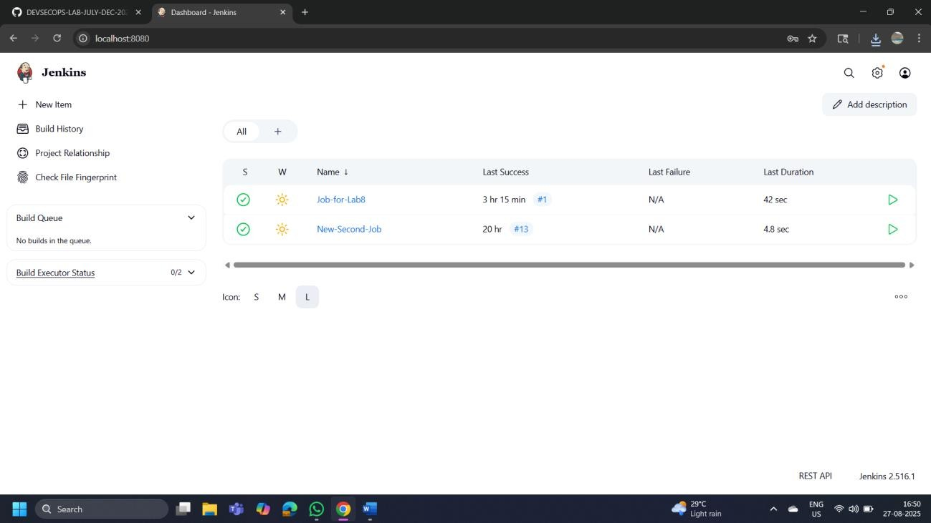

1.2

In the Jenkins dashboard, click on
New
I
tem

1.3 Select the Freestyle project while creating a Jenkins job, provide a custom job name, and click on OK

1.4 Now, in the Configure page, navigate to Source Code Management from the left navigation bar, select Git, and then provide the Git repository URL
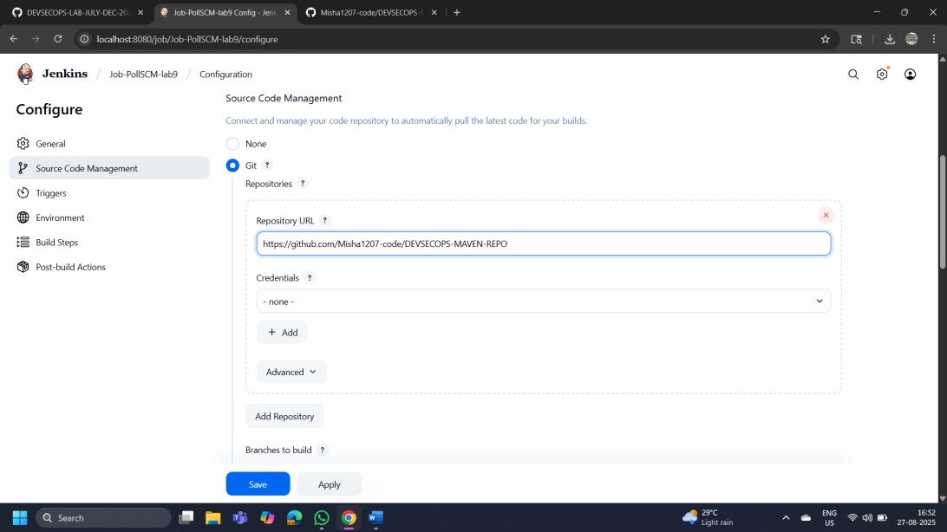

1.5 Now, navigate to Build Environment, click on Poll SCM, provide H/2**** under the Schedule section, and then click on Save (Triggers Section)
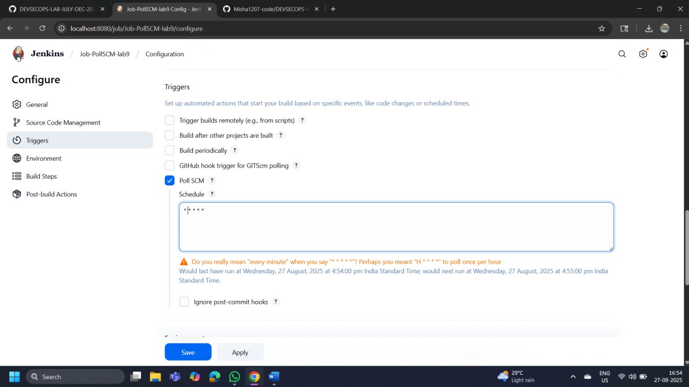

1.6 Then, click on Build Now to configure a build, and you will be able to view the successful build in the Console output section.
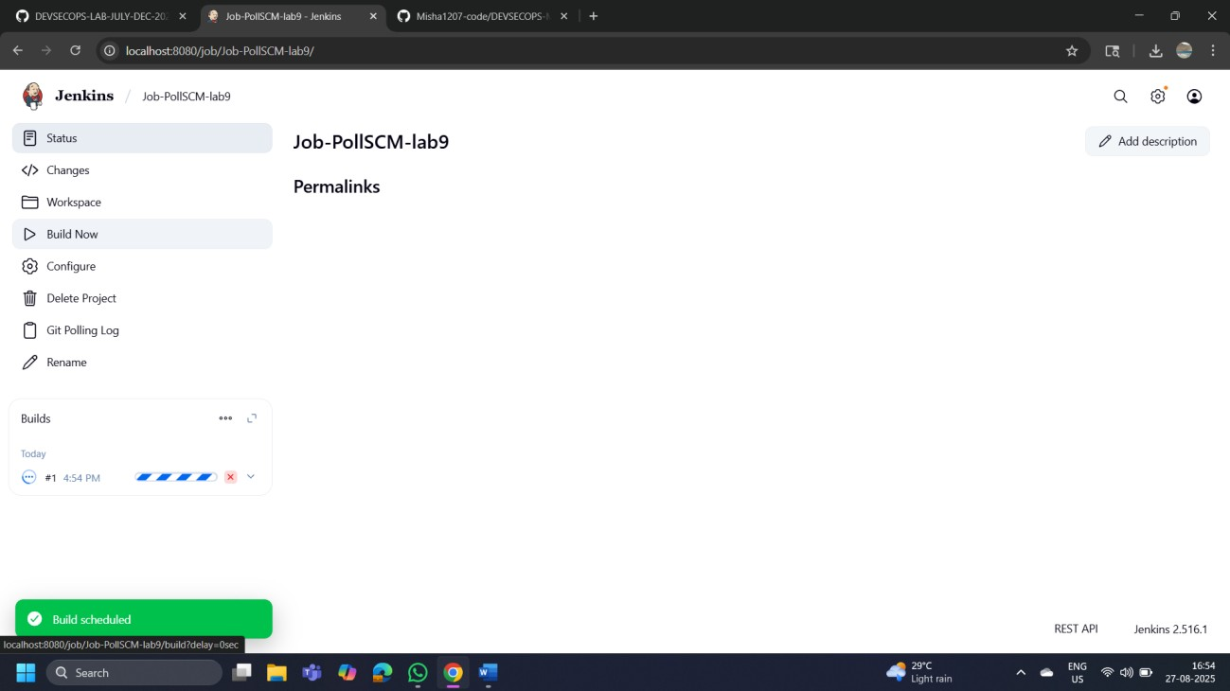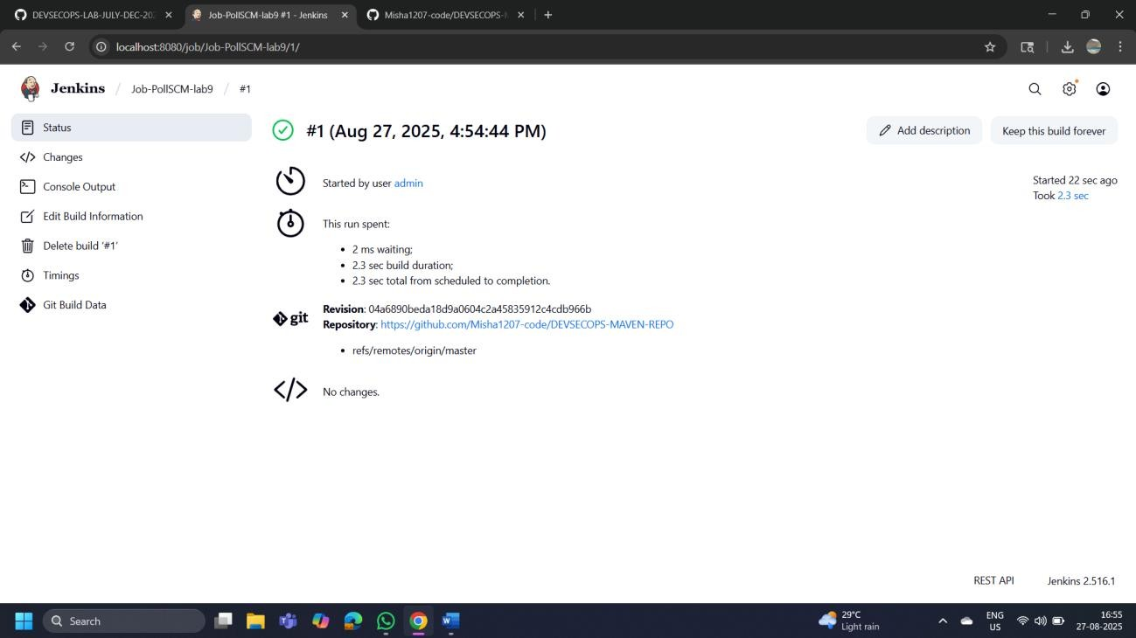

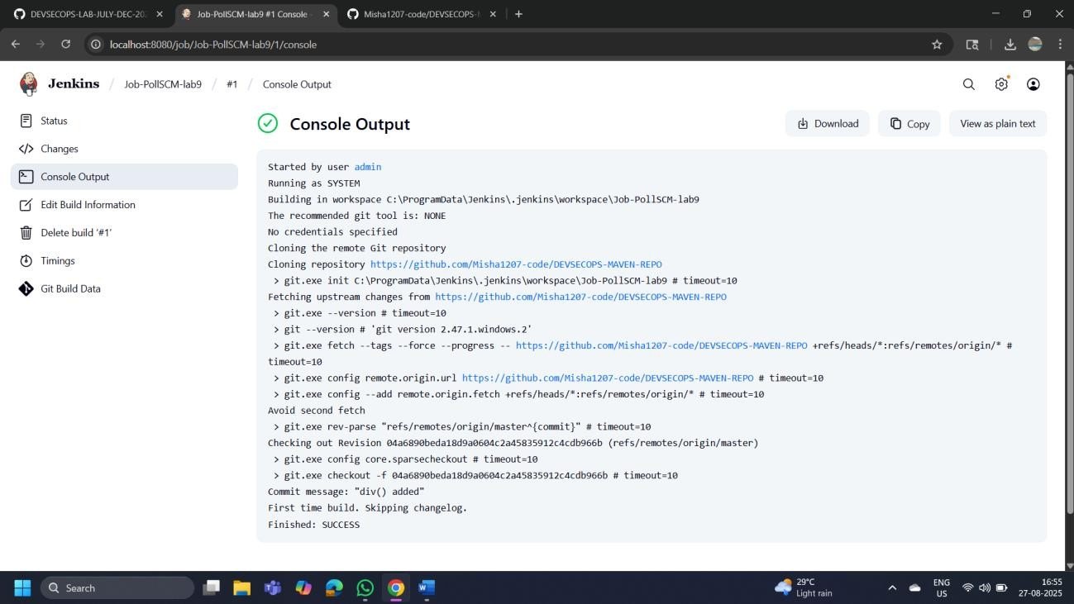

You can see that the build is configured successfully.

By following these steps, you have successfully set up poll SCM configuration in Jenkins for automating build triggering and optimizing resource usage on Jenkins servers.

